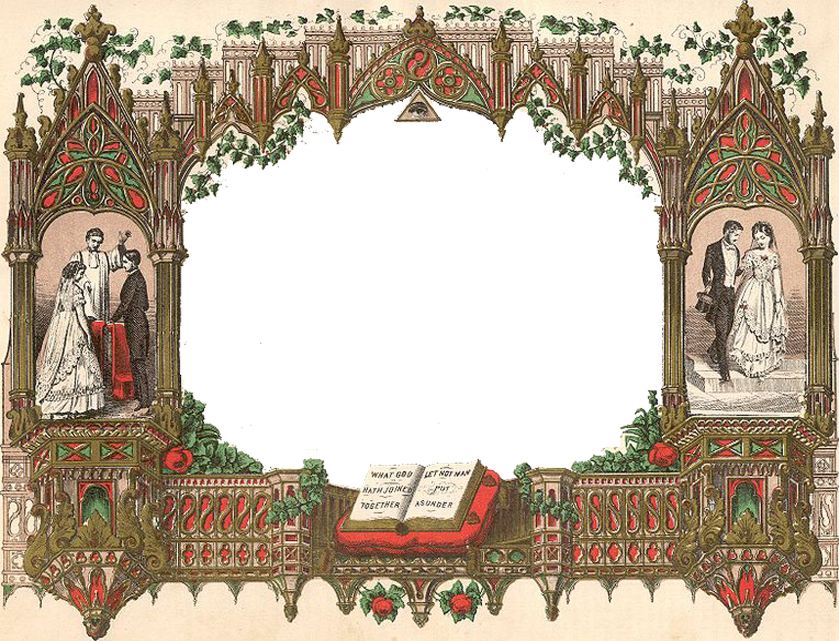

Holy Matrimony

Certificate Of Marriage

This is to Certify That

Mr. name and Miss name

Were by me, United in Marriage
In accordance with the laws of the State of state
in the City of city

On the xxxx day of month In the year xxxx

Officiated by officiant name

